

Registering with the

NICE Investigate Community Portal

Table of Contents
Introduction 2
How to register your Organisation 3
1. Respond to the registration request from North Yorkshire Police 3
2. Select “Register for Community Portal” 3
3. Select “Register Now” 3
4. Create your Business Account. 4
5. Verify your Account. 5
6. Login to your Account 6
Account Setup. 7
1. Confirm Business location. 7
2. Manage Users. 8
2.1 Add new user 8
3. Manage Groups (Business locations) 10
3.1 Add new Group 10
3.2 Group Location 11
4. Cameras Registration 12
4.1 Camera Management 12
4.2 Add a new Camera 12

Introduction
Thank you for agreeing to register with the NICE Investigate Community Portal.
Your CCTV cameras can help North Yorkshire Police deter and solve crime. Registering your cameras will streamline the information exchange, making it easier for North Yorkshire Police to identify which of your cameras may have evidential footage and it will simplify the process of making it available to an Investigating Officer.
This guide covers how you register your organisation, branches, users and CCTV cameras. There is a separate guide showing you how to respond to CCTV requests through your NICE Investigate account.
These guides along with more information on the NICE Investigate Community Portal and how the use of it benefits both you and North Yorkshire Police can be found at www.northyorkshire.police.uk/digitalevidence. If you have any questions or have any issues with the registration process please email: digitalevidence@northyorkshire.police.uk

Note: It is critical that your CCTV system is set to the correct time. Please compare your CCTV system time to that on an internet device i.e. a smart phone and update your CCTV system time as required.

How to register your Organisation

Respond to the registration request from North Yorkshire Police
If you’ve requested to register and your organisation is not currently registered with the Community Portal, then North Yorkshire Police will send you an email requesting that you register as shown below:
Note: The email will be sent via NICE Investigate from the email address “noreply@digital-policing.co.uk”
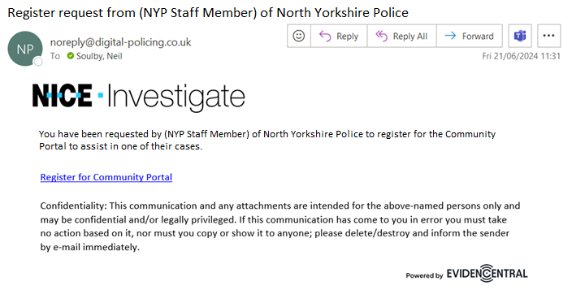

Select “Register for Community Portal”
In your invitation email, select “Register for Community Portal”.

Select “Register Now”
Once you have clicked on the link, the NICE Investigate Community Portal Login page will appear in a new tab in your browser as shown below:
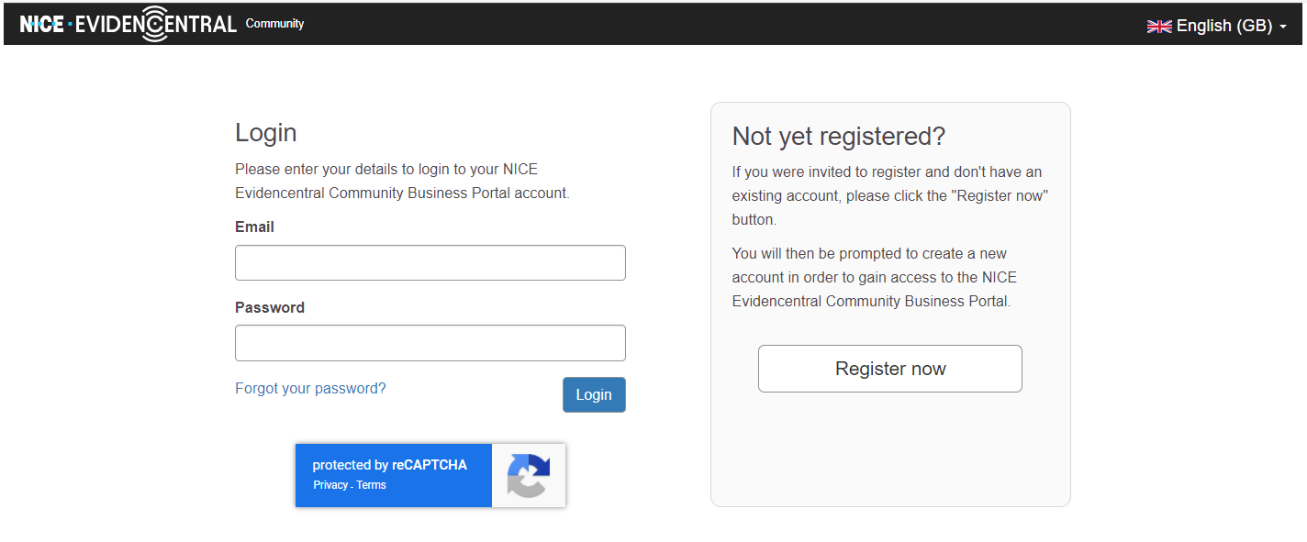

Create your Business Account.
Enter your email address and then enter a password. The password must be at least 10 characters long.
Select “Register”
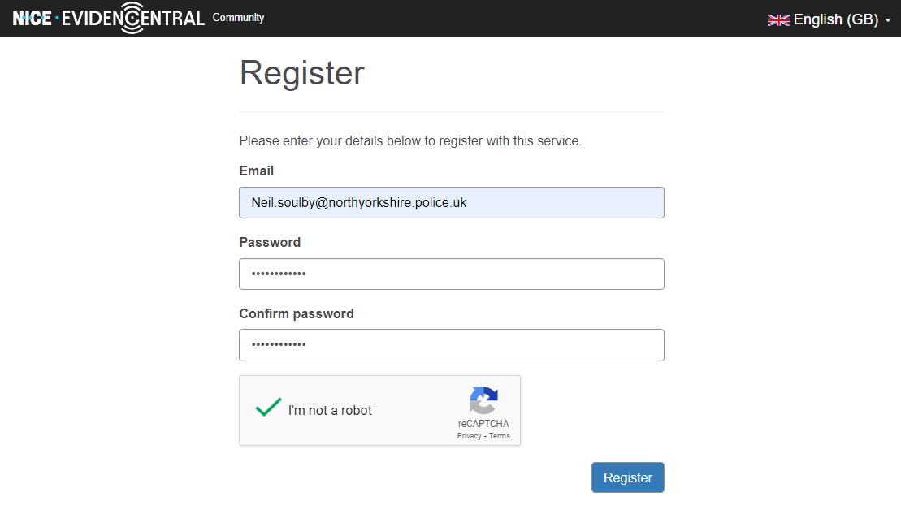

Verify your Account.
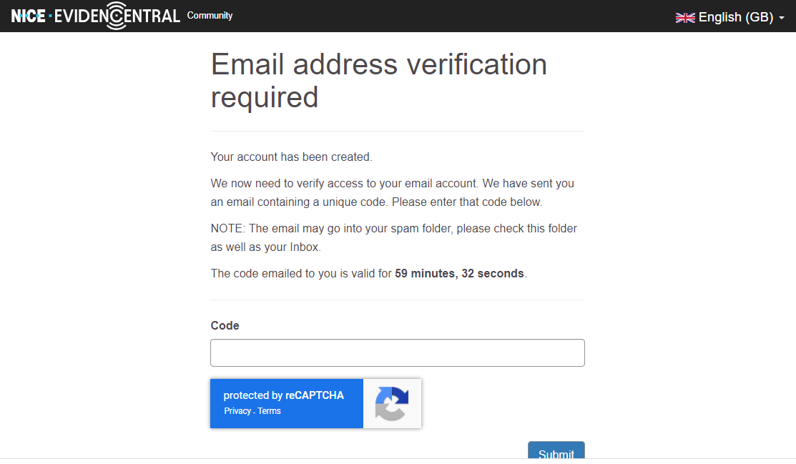
Check your inbox for the registration code (you may need to check your spam folder if you can’t find it in your inbox)
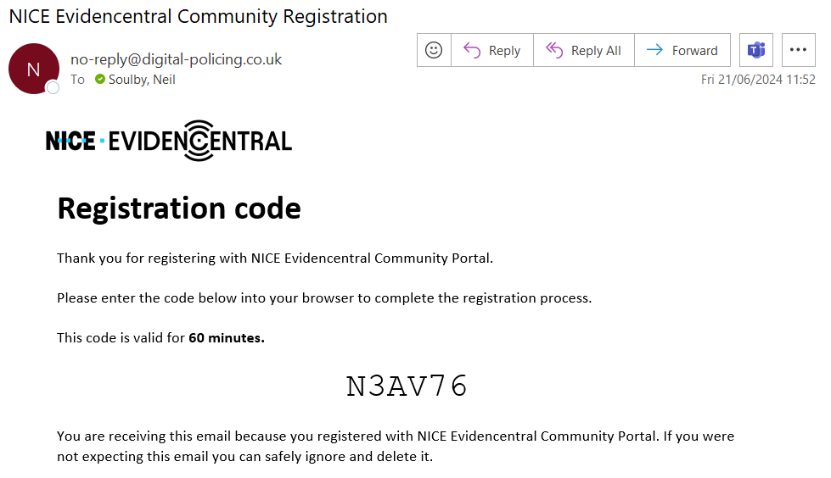
Enter the registration code you receive as shown below and select “Submit”.
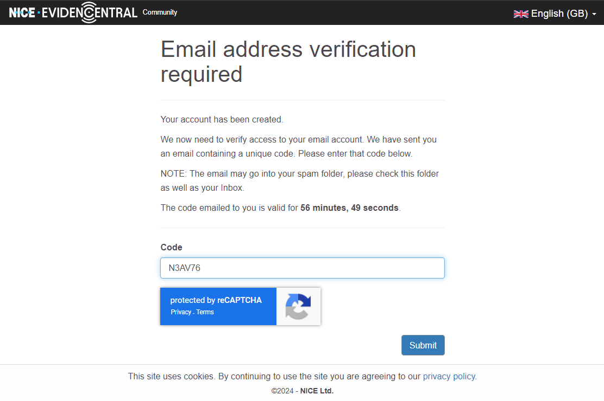
You will then receive confirmation that your account has been verified.
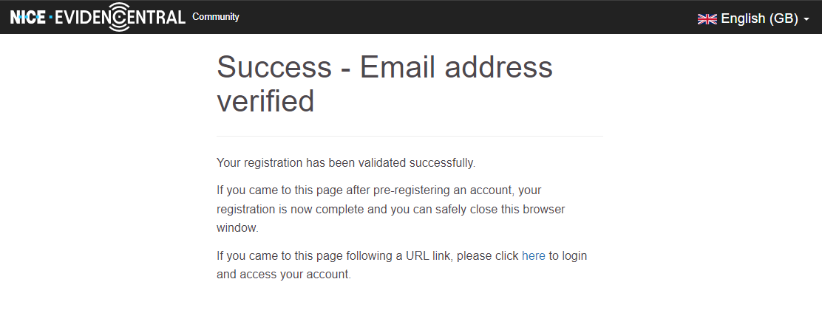

Login to your Account
Select on “Here” in verification screen (screenshot above) to access your account.
Once you’ve logged in you will be presented with a registration screen. Enter your details as required ensuring a full company address.
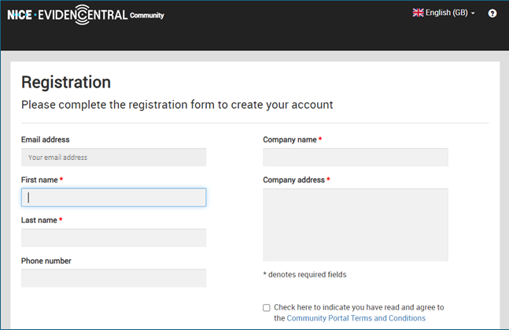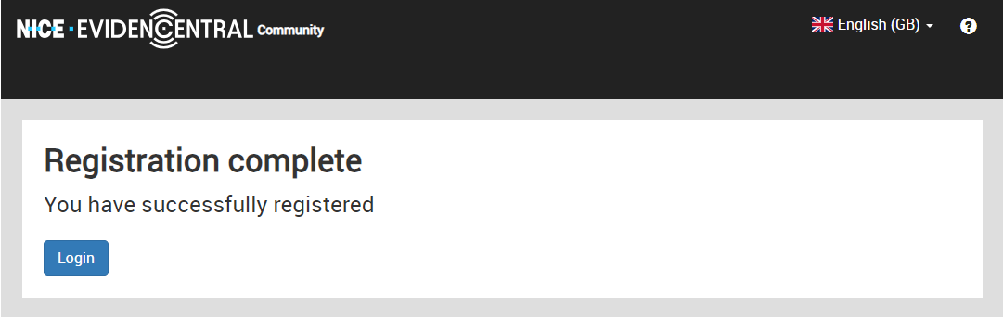
Your organisation is now registered. Please log into your account to complete the setup.

If you have any issues in the registration process or have any questions in relation to business registration then please email digitalevidence@northyorkshire.police.uk

Account Setup.

Confirm Business location.
In your account Select. “My Account” / “Business details”
Please check that your business is correctly located on the map. If it is not correct, simply move the pin on the map into the correct location.
Select “Save Changes” to confirm update.
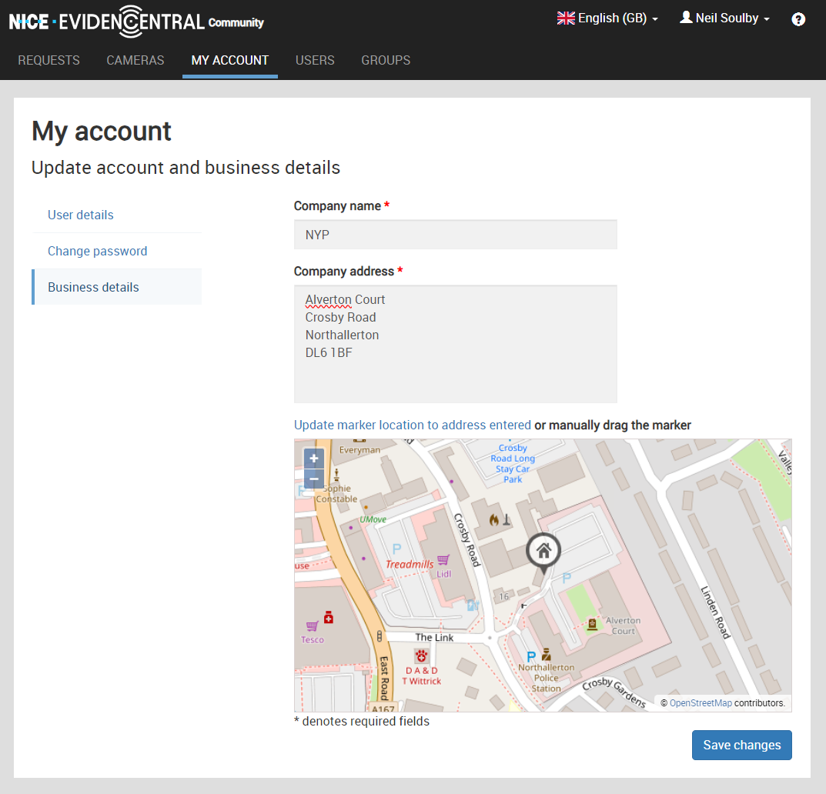

Manage Users.
You may wish to set up additional users in your company who have responsibility your CCTV.
Users can be managed as the “Primary Business Contact” or “Admin” users for your Community Portal Account for your business.
You are also able to assign users in your Community Portal.

2.1 Add new user
In your account select “Users” then “Add new user”
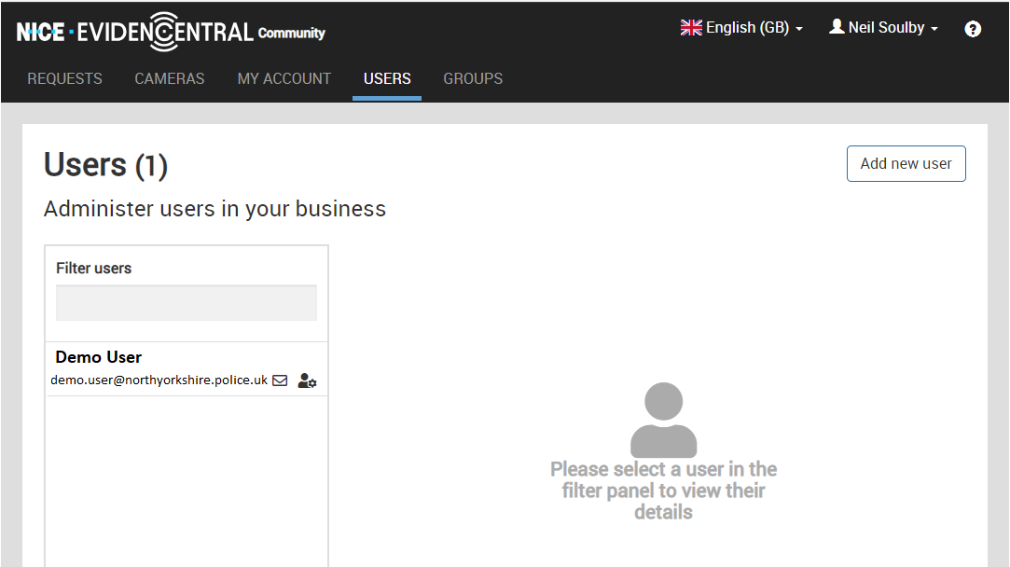

Any new user will have to register their account and verify their email as was required.
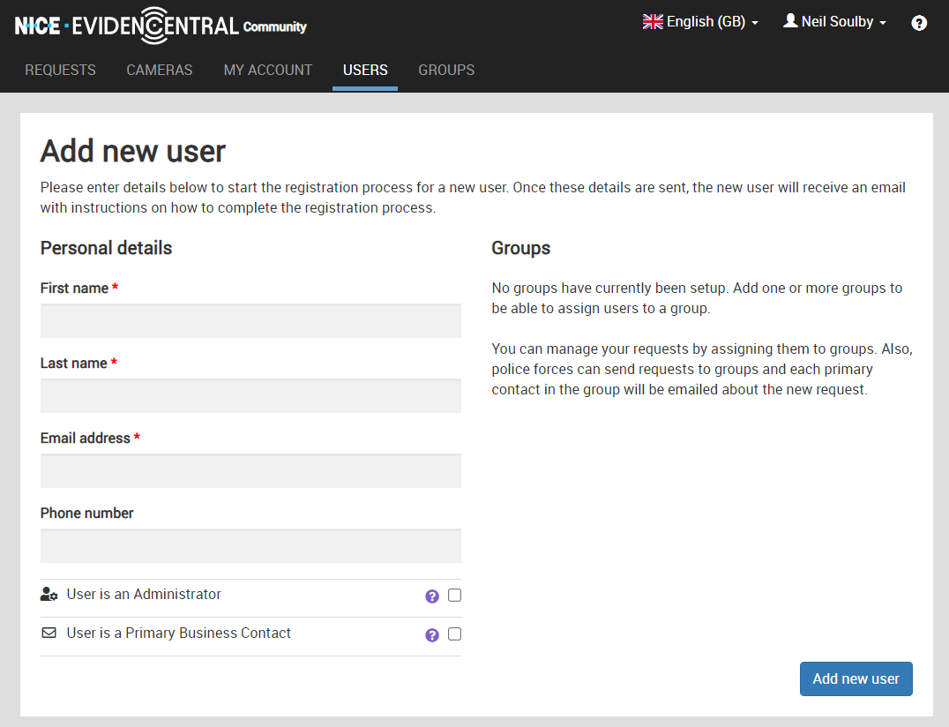

Manage Groups (business locations)
The Community Portal allows businesses to add additional locations known in the system as “Groups”. These could be branches linked to your business.

To manage your groups select “Groups”
Selecting a group listed will allow you to assign users to each group.

Add new Group
Select “Groups” and then “Add new group”
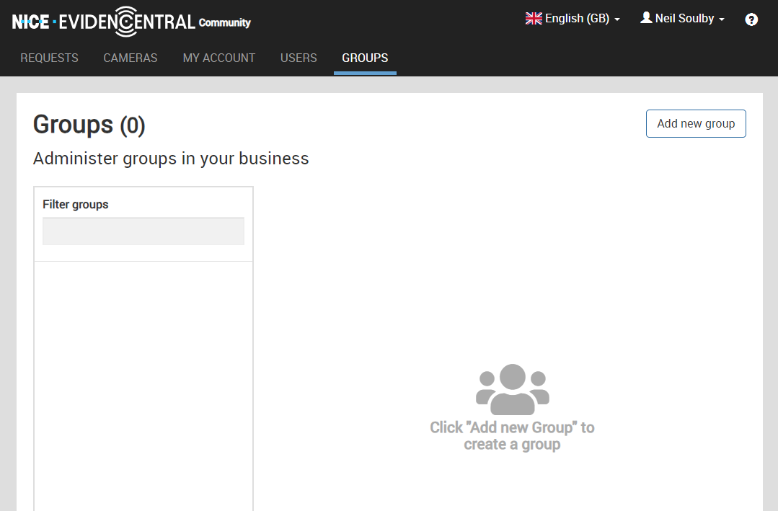
Enter the Group name (name of business location)

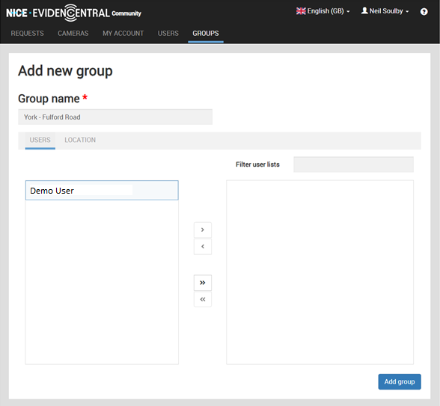
The users tab allows you to assign users to this Group using the arrow buttons.

3.2 Group Location
If your addition group (business) has a physical location you need to select “Assign a location to this group”.
Enter the full address and then select “Update marker location to the address entered” or if that doesn’t work or is not accurate simply move the pin on the map.
When you’ve completed registering your new group select “Add Group”
Your group will be added to your account for you to manage.
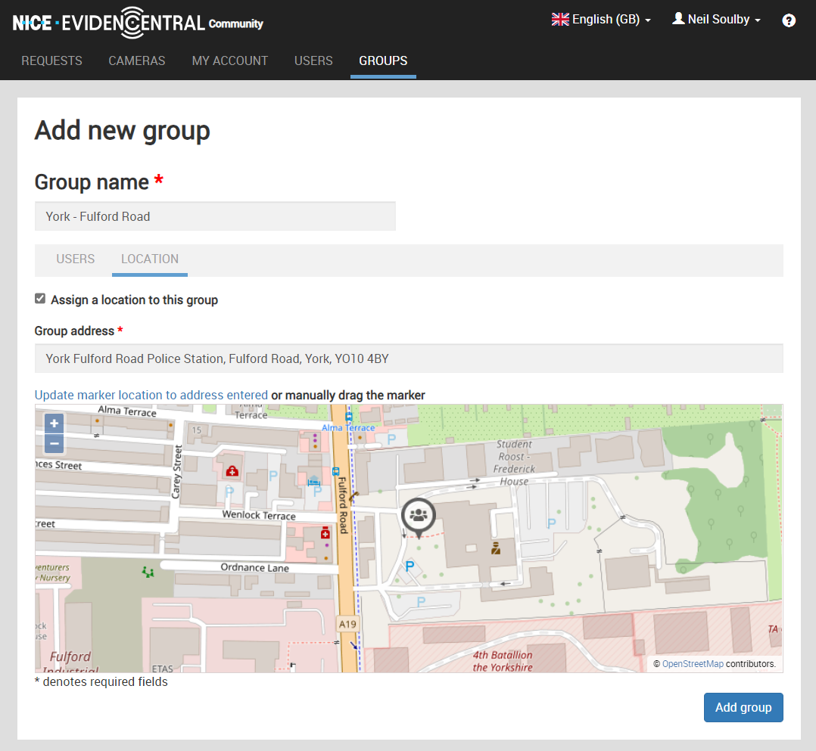

Cameras Registration
You may wish to register your cameras to your account, this is especially beneficial to the police force when any of your external facing cameras are registered as they may assist the police in tracking down suspects, missing people etc outside your premises.

4.1 Camera Management
You can manage all your registered cameras by selecting “Cameras” in your account.
Any camera registered will show in your list, but also on the map.
To update the camera select on it from the list. Existing cameras can be updated and removed if required.
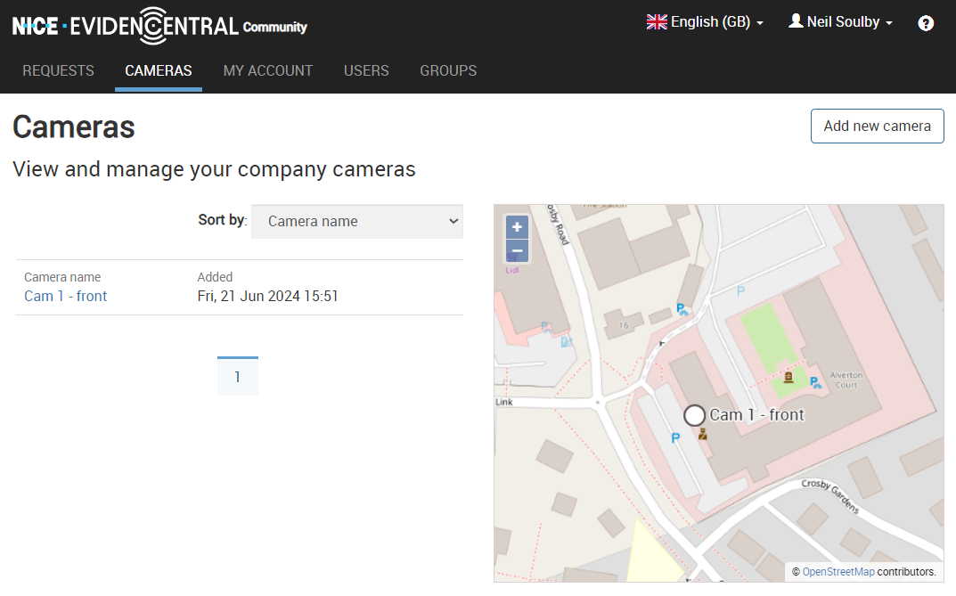

4.2 Add a new Camera
To register your camera, select “Cameras” and then “Add new camera”

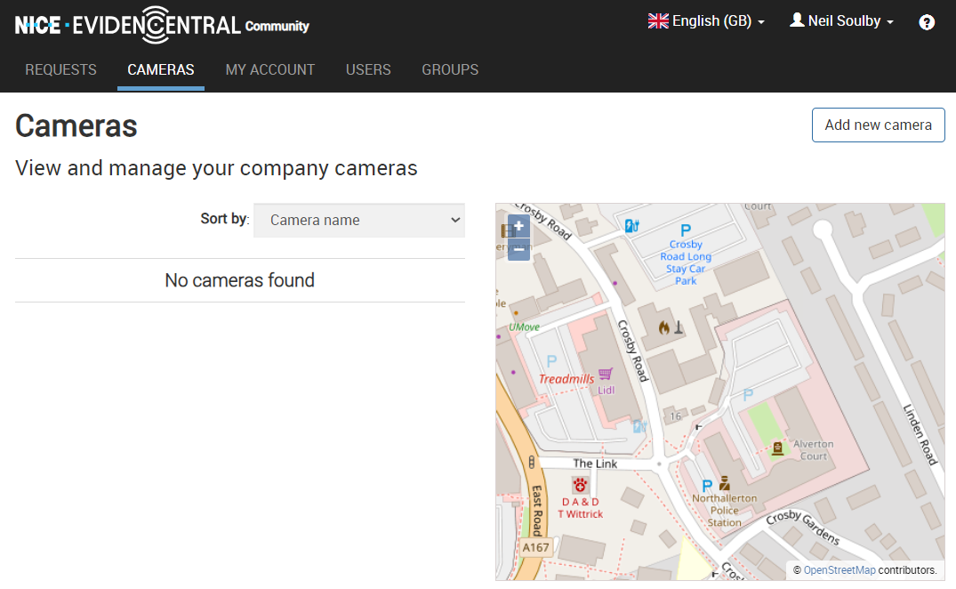
Enter the details of the camera.
NOTE: The most important information for Police and for businesses to reduce requests are “Location on the map” and “Camera Notes”
- Camera Name
  - Name the camera something which provides a meaningful description ie “camera – front door”
  - This camera name is displayed on the map
- Internal Name
  - This should be the name of the camera shown on your CCTV system ie camera 1
- Camera Make
  - Not important, but feel free to add.
- Camera Model
  - Not important, but feel free to add.
- Location on the map:
  - Please ensure the location is accurate.
  - The best way to do this is to zoom in and drag the camera pin to the correct location.
- Camera notes:
  - To improve the quality of requests for footage, please enter if this camera faces externally to your business. If it does enter a brief description of what the camera can see.
    - I.e. “External Camera – Faces south down main street covering the pavement a road.
When you’ve completed the details select “Add Camera”
