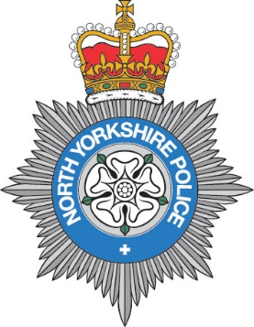
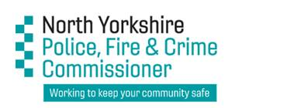

FREEDOM OF INFORMATION REQUEST REFERENCE NO: 0001.2021-22

I write in connection with your request for information which was received by North Yorkshire Police on 01 April 2021. I note you seek access to the following information:

- The number of interim and full Stalking Protection Orders applied for to the courts by your force since January 2020.

- The number of interim and full Stalking Protection Orders granted by the courts following an application through your force since January 2020.

- The number of interim and full Stalking Protection Orders rejected by the courts following an application through your force since January 2020.

- The number of interim and full Stalking Protection Orders which have not yet been heard by the courts following an application through your force since January 2020.

Extent and Result of Searches to Locate Information
To locate the information relevant to your request searches were conducted within North Yorkshire Police. I can confirm that the information you have requested is held by North Yorkshire Police.

Decision
I have today decided to disclose the located information to you.

The information provided below is true as on 12 April 2021.

1) 1 Interim & 1 Full Stalking Protection Order applied for since January 2020.

2) 1 Interim & 0 Full Stalking Protection Orders granted since January 2020.

3) 0 Interim & 0 Full Stalking Protection Orders rejected by the courts since January 2020.

4) As on 12 April 2021 there were 0 Interim & 0 Full Stalking Protection Order applications pending a hearing.

Please note the data reflects only Stalking Protection Orders pursued by North Yorkshire Police and none that may have been applied for in private proceedings.

Please note that systems used for recording information are not generic, nor are the procedures used locally in capturing the data. It should be noted therefore that this force’s response to your questions should not be used for comparison purposes with any other responses you may receive.

